**CREATE NODE-RED SERVICE**

|  |  |
| --- | --- |
| Team ID | PNT2022TMID50177 |
| Project Name | Smart Waste Management System for Metropolitan Cities |

Step 1: Login into IBM CLOUD account  
  
Step 2: In catalog, search for Node-RED application

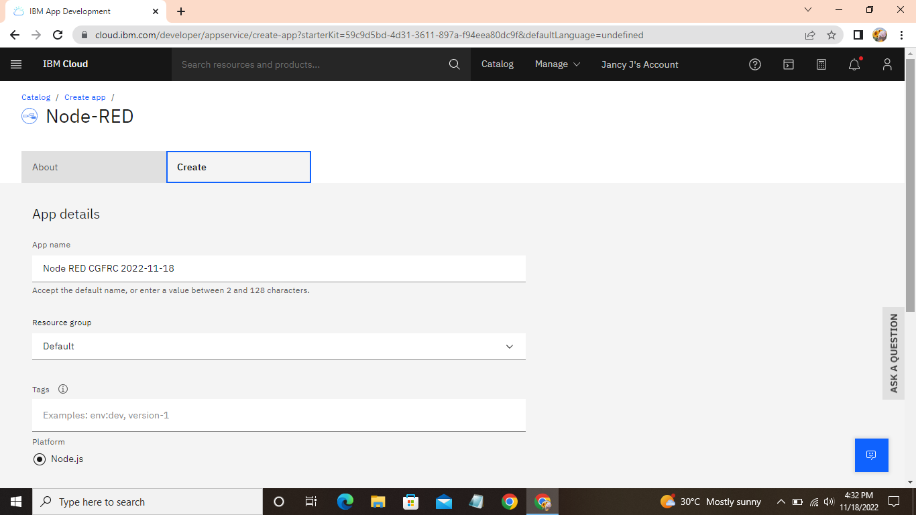  
  
Step 3: Enter the project details and click on create  
  
Step 4: Click on deploy option and deploy  
  
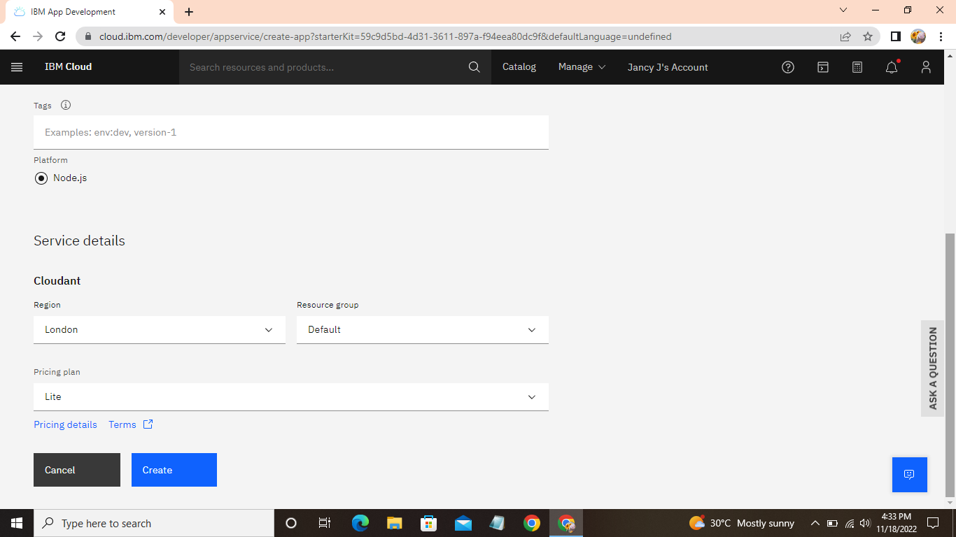  
  
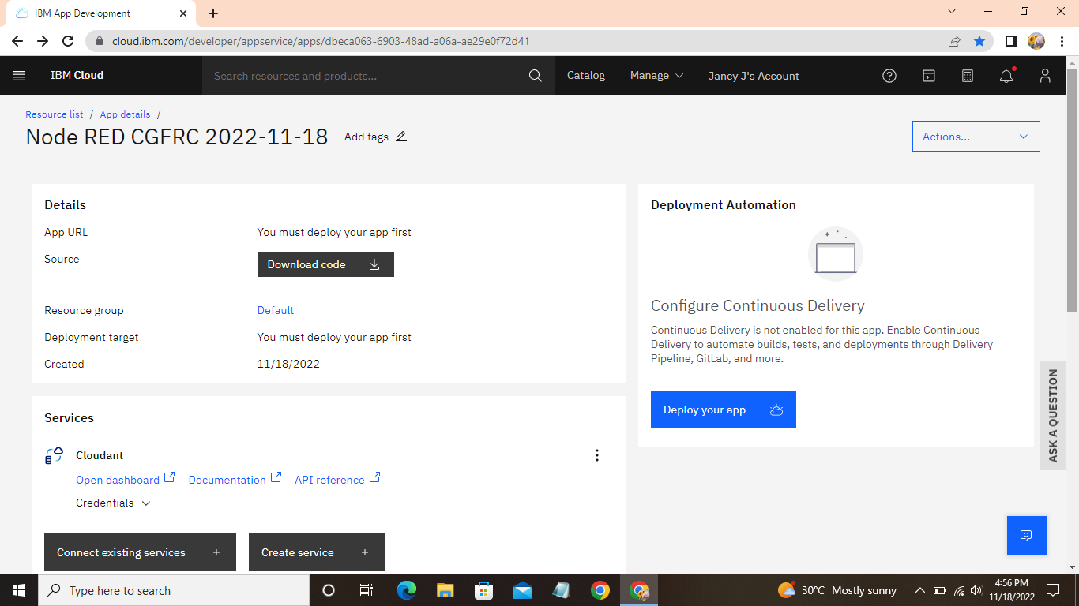

Step 5: Set up the environment for create Node-RED application  
  
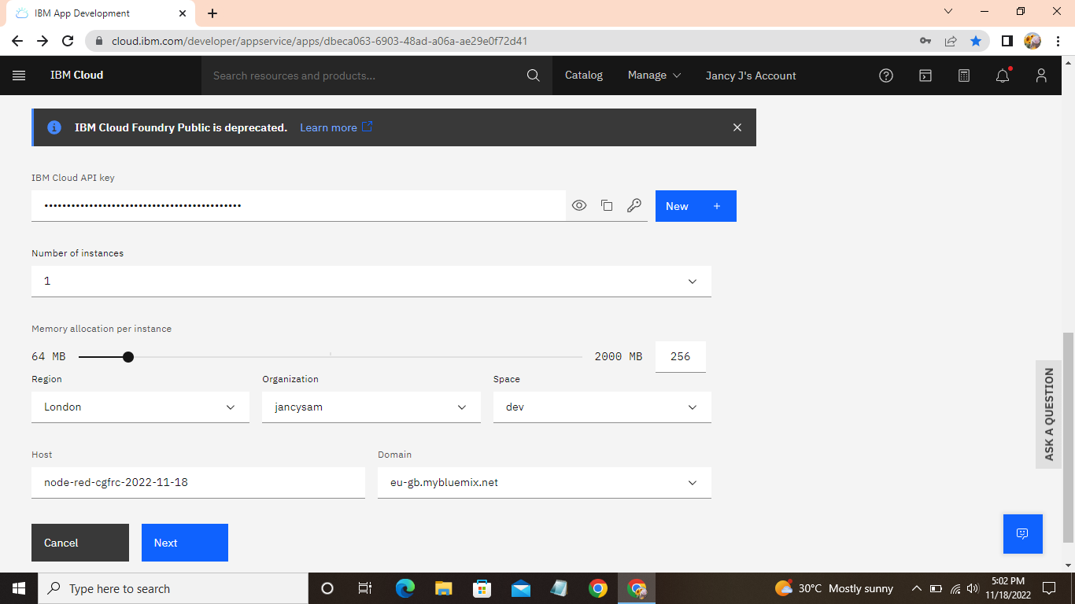  
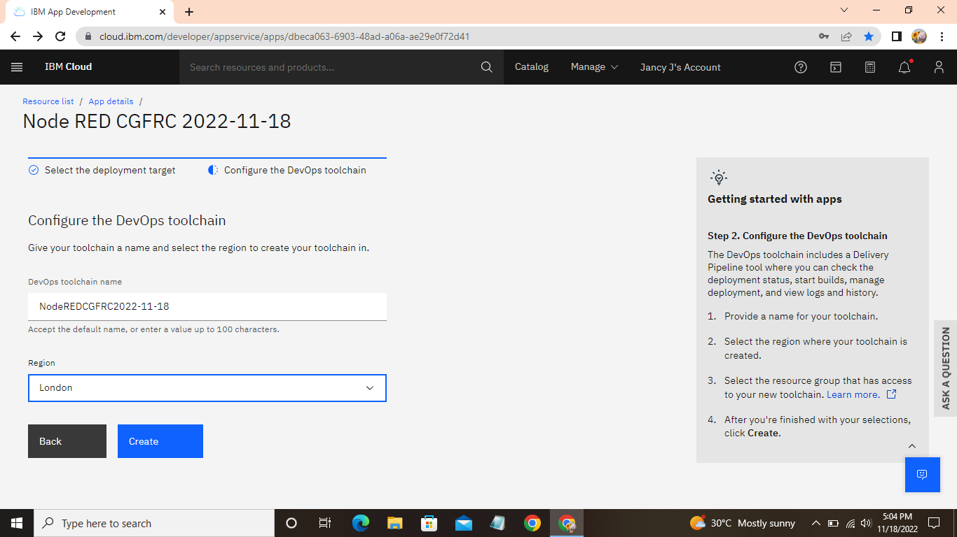  
  
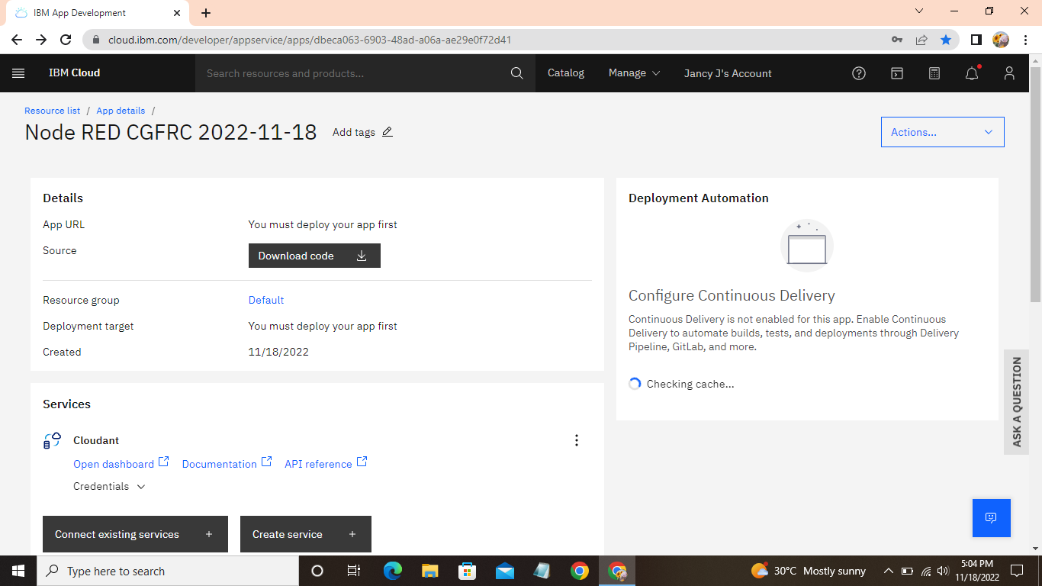  
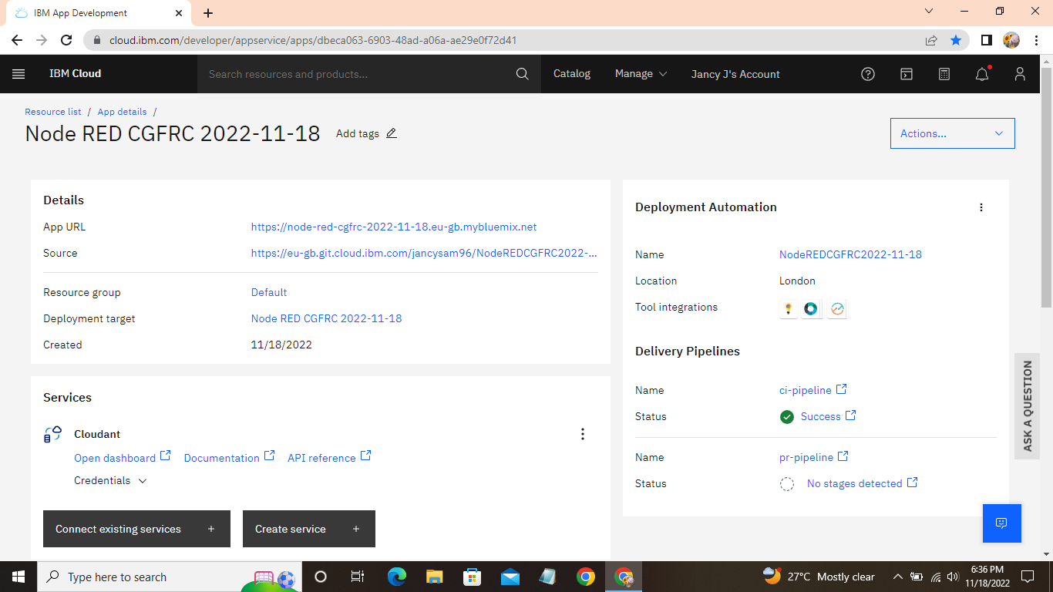

Step 6: Log in to IBM Cloud and open “Resource list” and then click cloud application for Node-RED from Developer Tools option available in Resoure list.  
  
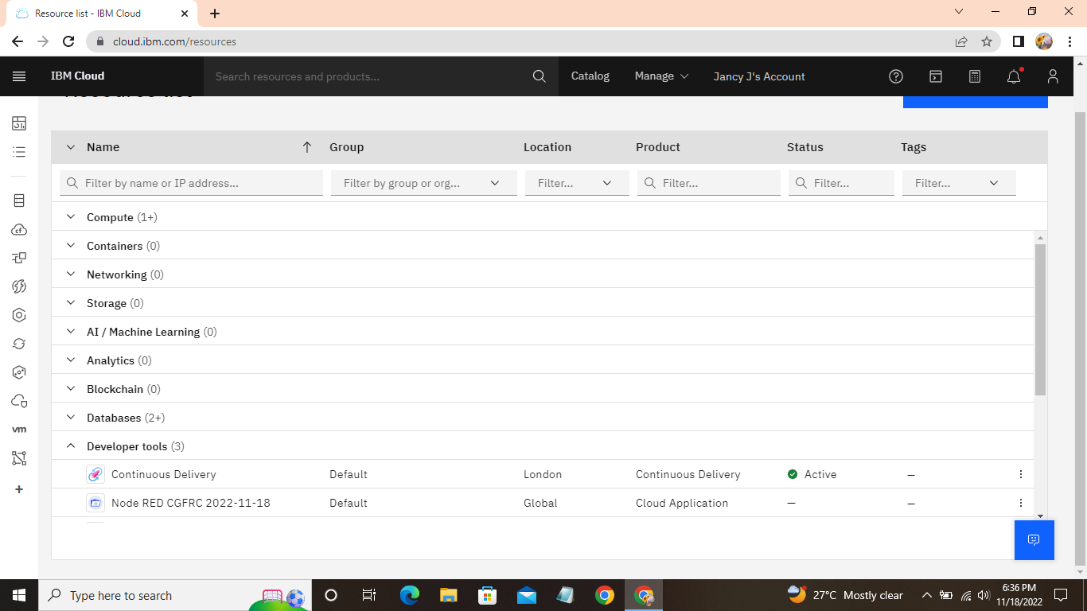  
  
  
Step 7: After click this, you have to finish some steps for create and installing the Node-RED application  
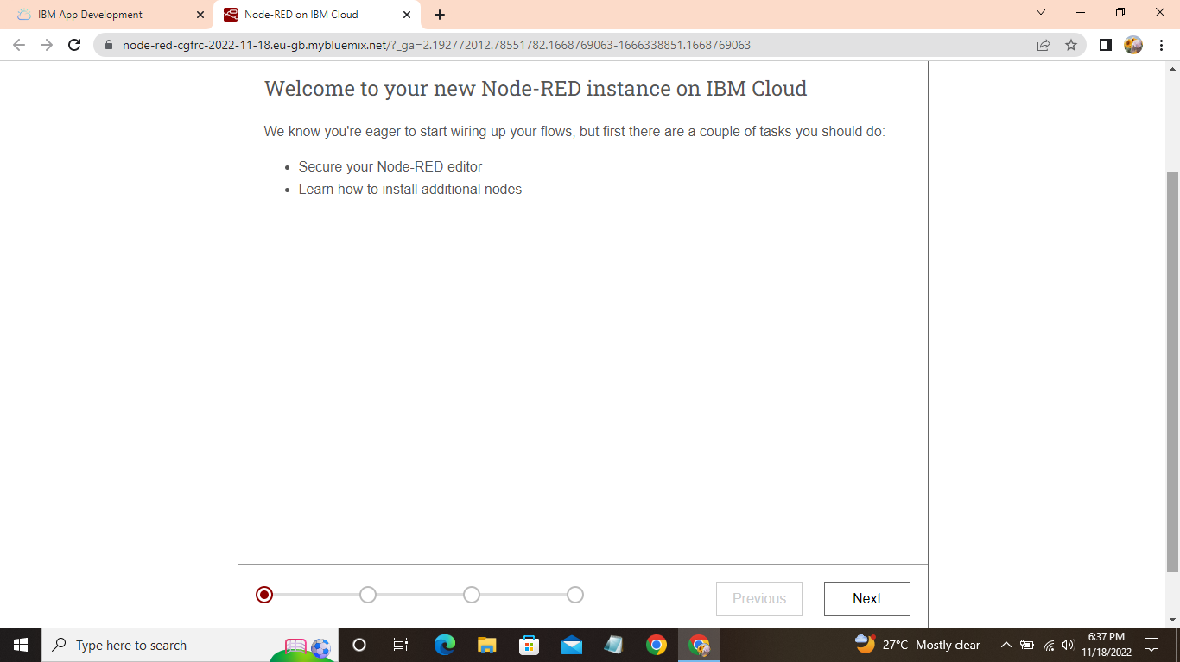  
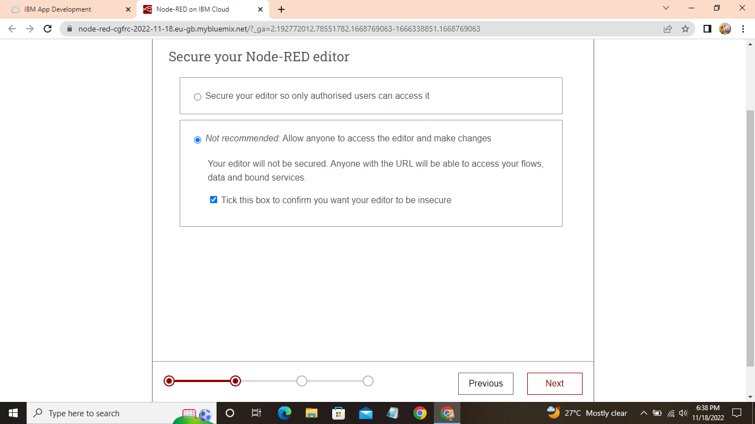  
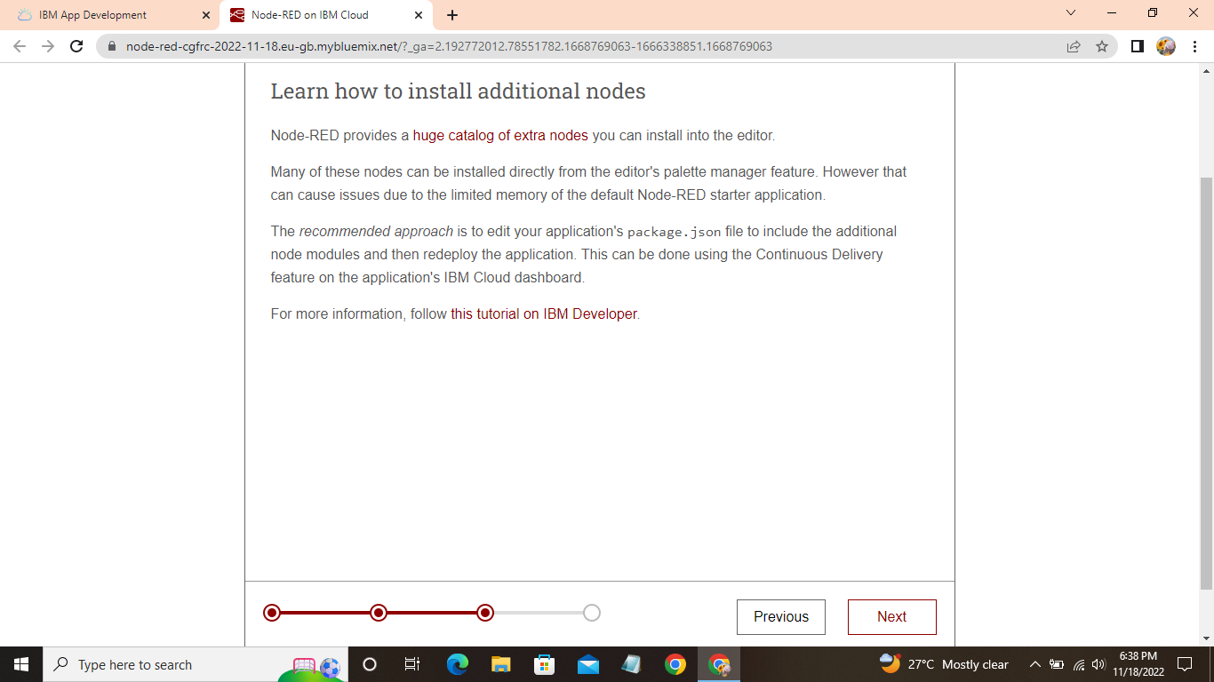  
  
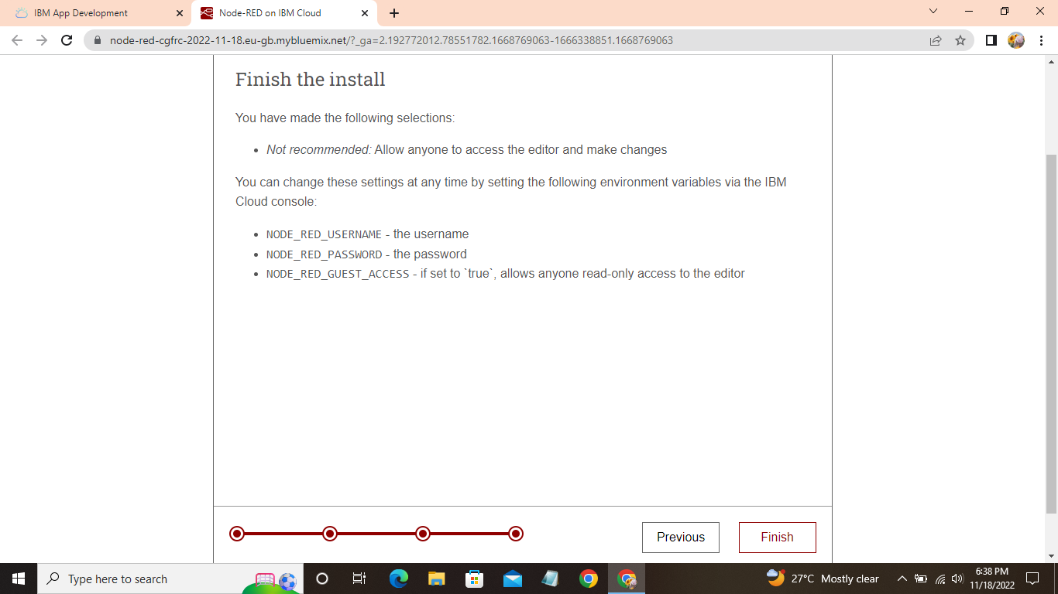

Step 8: Once you finish the installation, Node-RED is gets loaded and finally Node-RED application is created

